**Microprocessor and Computer Architecture**

**UE21CS251B**

**4th Semester, Academic Year 2021-22**

Date:

|  |  |  |
| --- | --- | --- |
| Name: Atharva Menkudle | SRN:PES2UG21CS104 | Section  B |

**Include in your submission**

ARM Assembly Code(1)

Output Screen Shot (1)

Week#____3______ Program Number: ____1___

Title of the Program

**Check whether a given number is present in array using Linear Search(Without SWI 0x02), if found move its position to R7 else move -1 to R6 ( if number not found)**

**Code:**

.DATA

A:.WORD 12,24,33,41,5

KEY:.WORD 41

.TEXT

LDR R0,=A

LDR R1,=KEY

LDR R5,[R1]

MOV R4,#1   @COUNTER

LOOP:LDR R2,[R0],#4

    CMP R5,R2

    BEQ FOUND

    ADD R4,R4,#1

    CMP R4,#6

BNE LOOP

MOV R3,#0

MOV R6,R5

B EXIT  @LABELS

FOUND:

MOV R3,#1

MOV R7,R2

    SWI 0X011

EXIT:SWI 0X011

**Output Screenshot:**

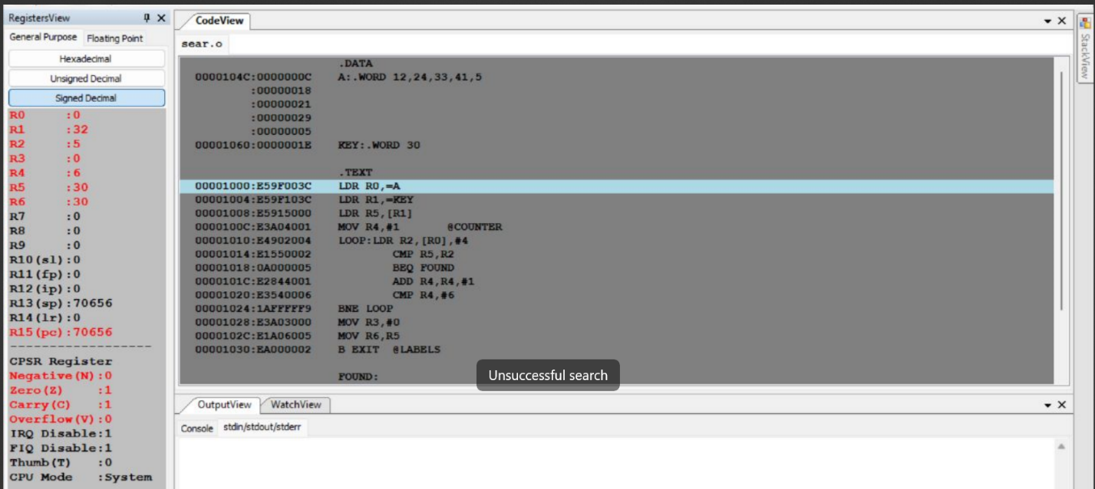

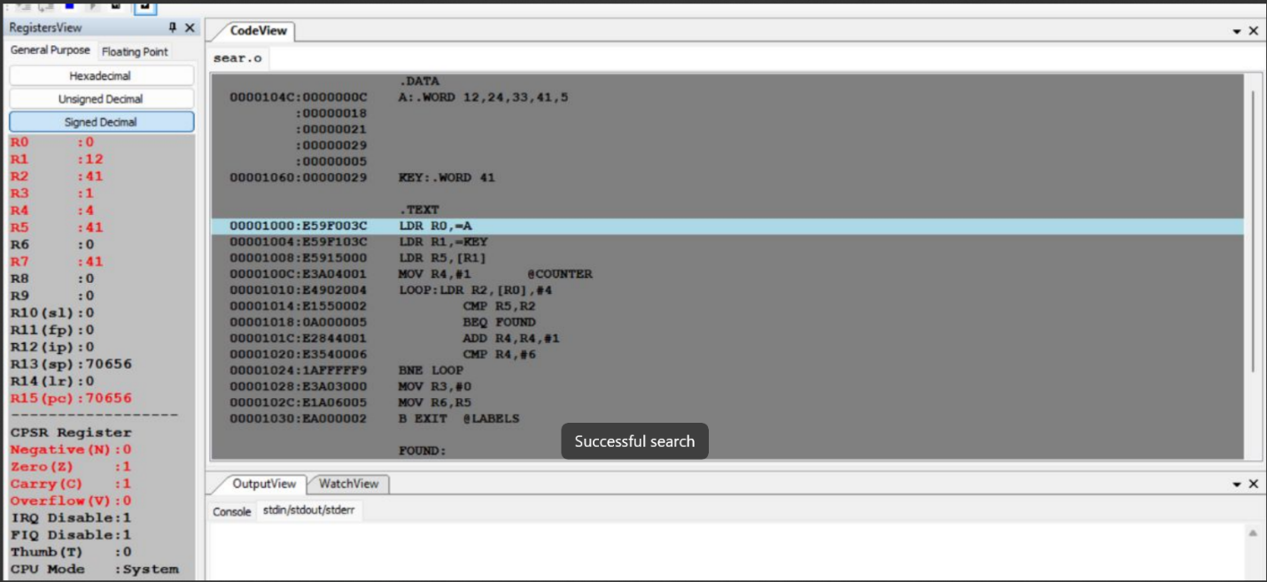

Week#____3_______ Program Number: ____2___

Title of the Program

**Generate Fibonacci Series and store them in an array.**

**Code:**

.data

a: .word 0,0,0,0,0,0,0,0,0,0

.text

LDR r0,=a

MOV r1,#0

MOV r2,#1

MOV r4,#2

STMIA r0!,{r1,r2}

BL fib

B exit

fib:

loop:

LDMDB r0,{r1,r2}

ADD r3,r1,r2

STR r3,[r0],#4

ADD r4,r4,#1

CMP r4,#11

BNE loop

MOV PC,LR

exit:

.end

**Output Screenshot:**

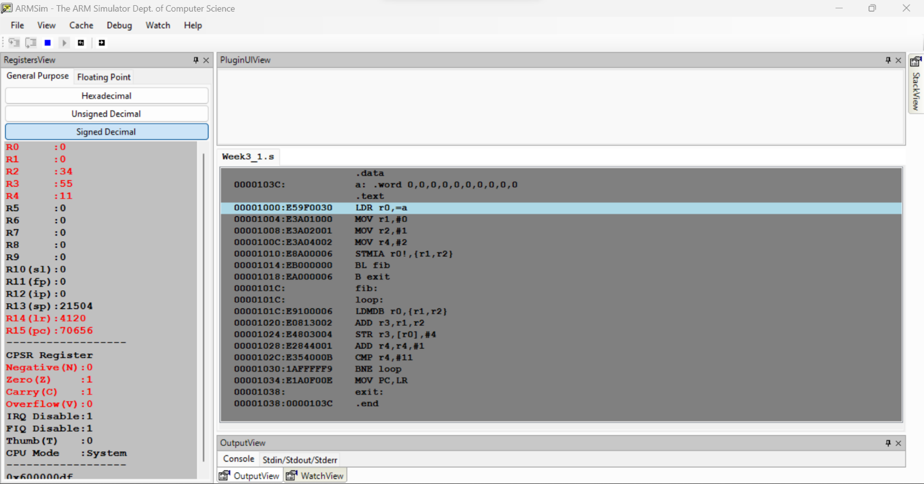

Week#____2_______ Program Number: ____3___

Title of the Program

**Write an ALP to find smallest number in an array of n 32 bit numbers**

**Code:**

.data

a: .word 16,10,32,52,4,9,20,13,90

b: .word -1

.text

LDR r0,=a

LDR r1,[r0],#4

LDR r4,=b

MOV r3,#1

loop:

LDR r2,[r0],#4

CMP r1,r2

MOVGT r1,r2

ADD r3,r3,#1

CMP r3,#9

BNE loop

B exit

exit:

**Output Screenshot:**

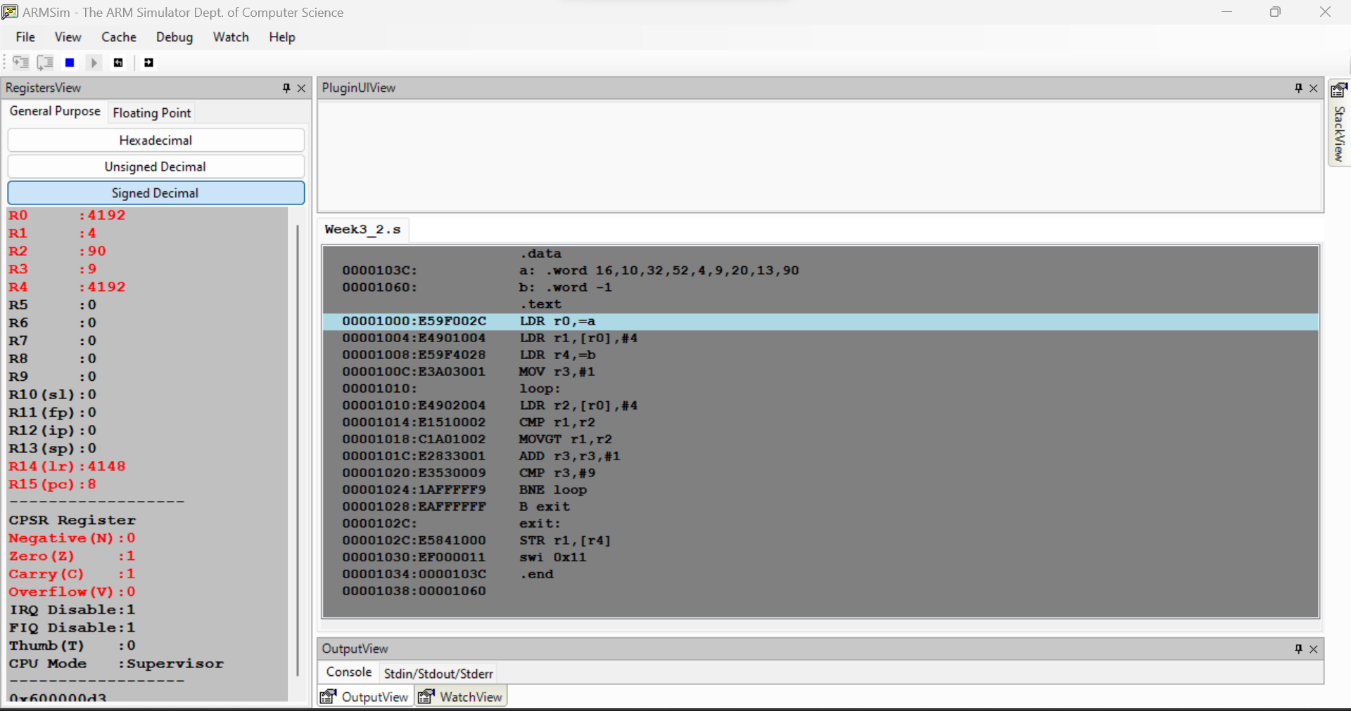

Week#____2_______ Program Number: ____4___

Title of the Program

**To perform Convolution using MUL instruction (Addition of multiplication of respective numbers of loc A and loc B)**

**Code:**

.data

a: .word 1,2,3,4,5,6,7,8,9

b: .word 10,20,30,40,50,60,70,80,90

c: .word 0

.text

LDR r0,=a

LDR r1,=b

LDR r2,=c

MOV r5,#0

MOV r6,#1

loop:

LDR r3,[r0],#4

LDR r4,[r1],#4

MUL r7,r3,r4

ADD r5,r5,r7

ADD r6,r6,#1

CMP r6,#10

BNE loop

B exit

exit:

STR r5,[r2]

swi 0x11

.end

**Output Screenshots:**

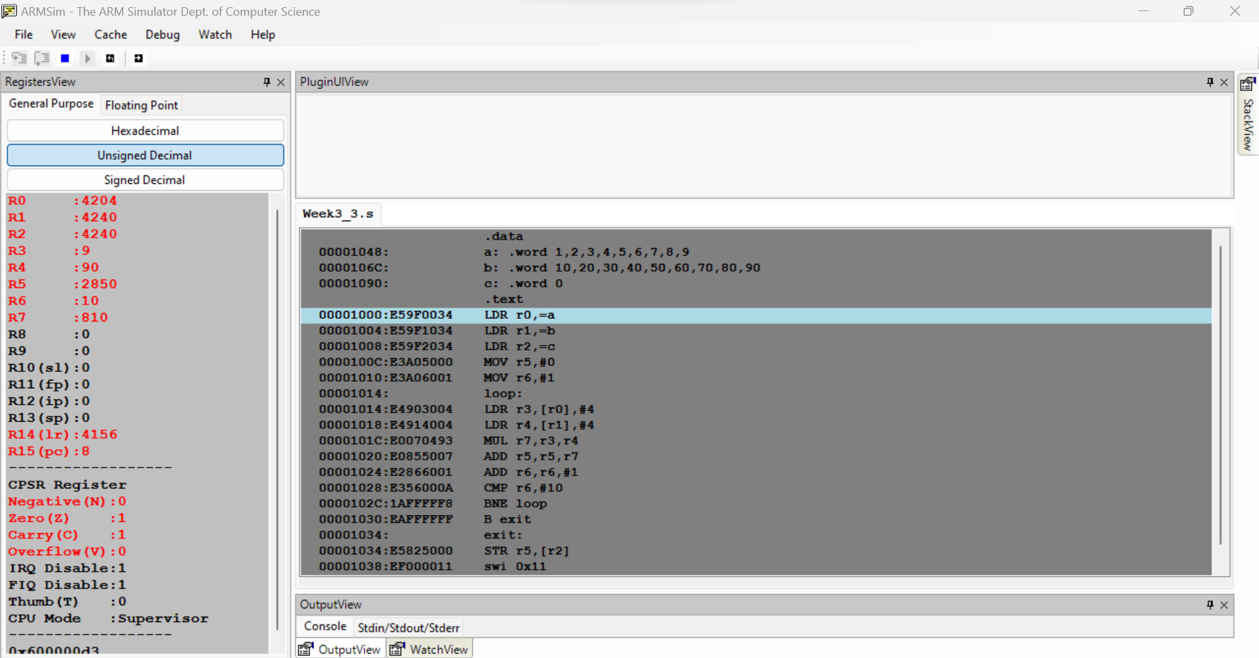

Week#____2_______ Program Number: ____5__

Title of the Program

**To perform Convolution using MLA instruction (Addition of multiplication of respective numbers of loc A and loc B).**

**Code:**

.data

a: .word 1,2,3,4,5,6,7,8,9

b: .word 10,20,30,40,50,60,70,80,90

c: .word 0

.text

LDR r0,=a

LDR r1,=b

LDR r2,=c

MOV r5,#0

MOV r6,#1

loop:

LDR r3,[r0],#4

LDR r4,[r1],#4

MLA r5,r3,r4,r5

ADD r6,r6,#1

CMP r6,#10

BNE loop

B exit

exit:

STR r5,[r2]

swi 0x11

.end

**Output Screenshot:**

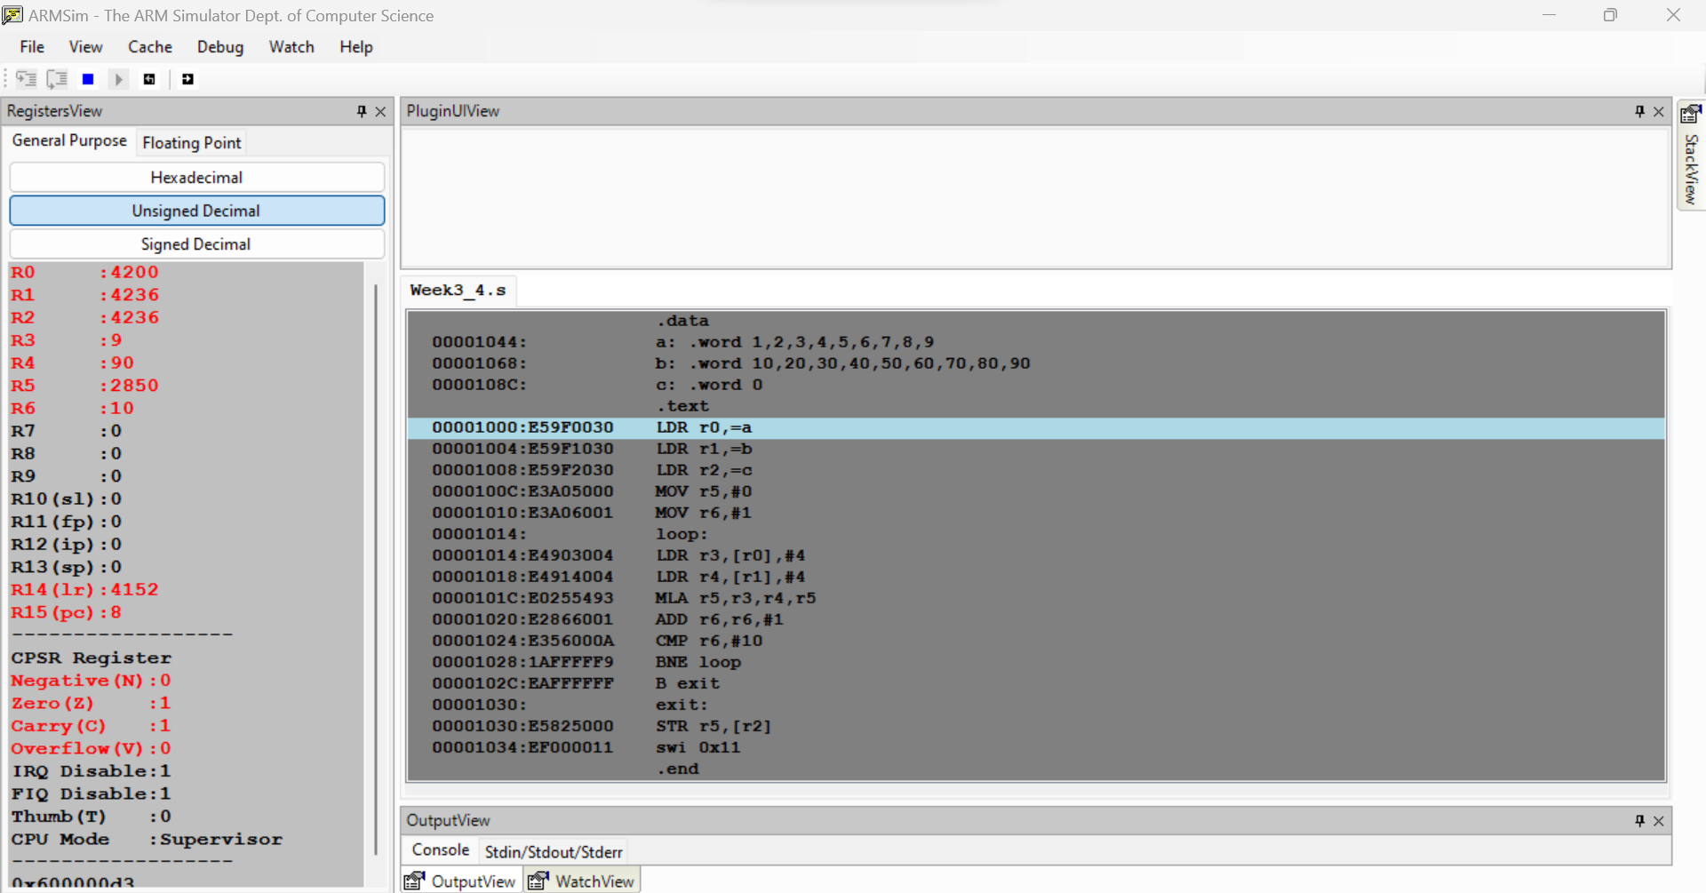

Week#____2_______ Program Number: ____6___

Title of the Program

**Write an ALP to find mul (add( a,b),c)**

**Code:**

.data

a: .word 0

stk: .word 0

.text

LDR r0,=a

MOV r1,#10

MOV r2,#20

MOV r3,#30

BL mulADD /*mul(add(10,20),30)*/

STR r6,[r0]

B exit

mulADD:

LDR r4,=stk

STR LR,[r4]

BL add

MUL r6,r5,r3

LDR LR,[r4]

MOV PC,LR

add:

ADD r5,r2,r1

MOV PC,LR

exit:

.end

Output Screenshot:

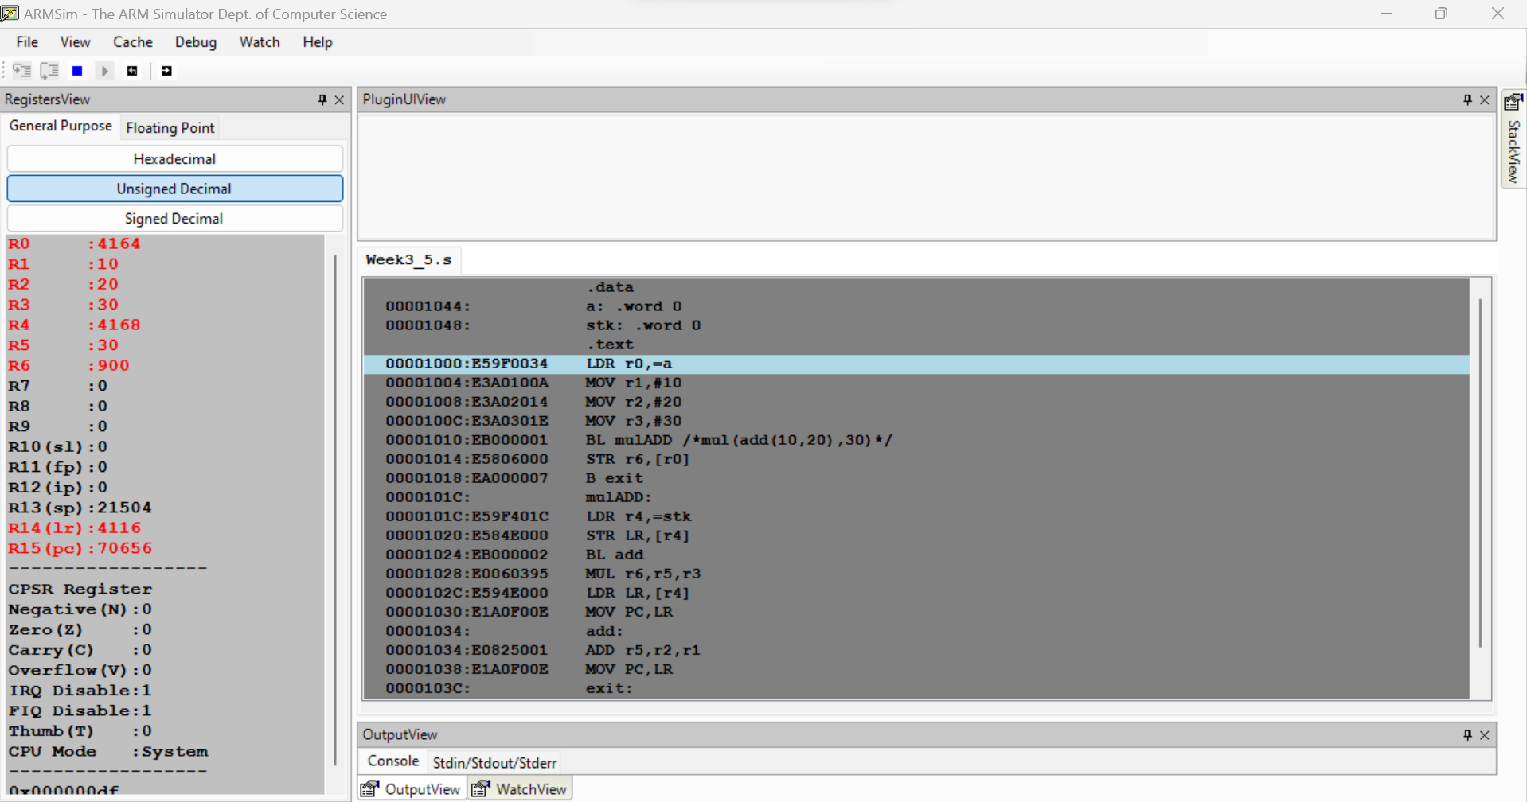

Week#____2_______ Program Number: ____7___

Title of the Program

**Write an ALP to find factorial using subroutine**

**Code:**

.data

a: .word 0

.text

LDR r0,=a

MOV r1,#10

BL fact

STR r2,[r0]

B exit

fact:

MOV r2,#1

loop:

MUL r2,r2,r1

SUB r1,r1,#1

CMP r1,#0

BGT loop

MOV PC,LR

exit:

.end

**Output Screenshot:**

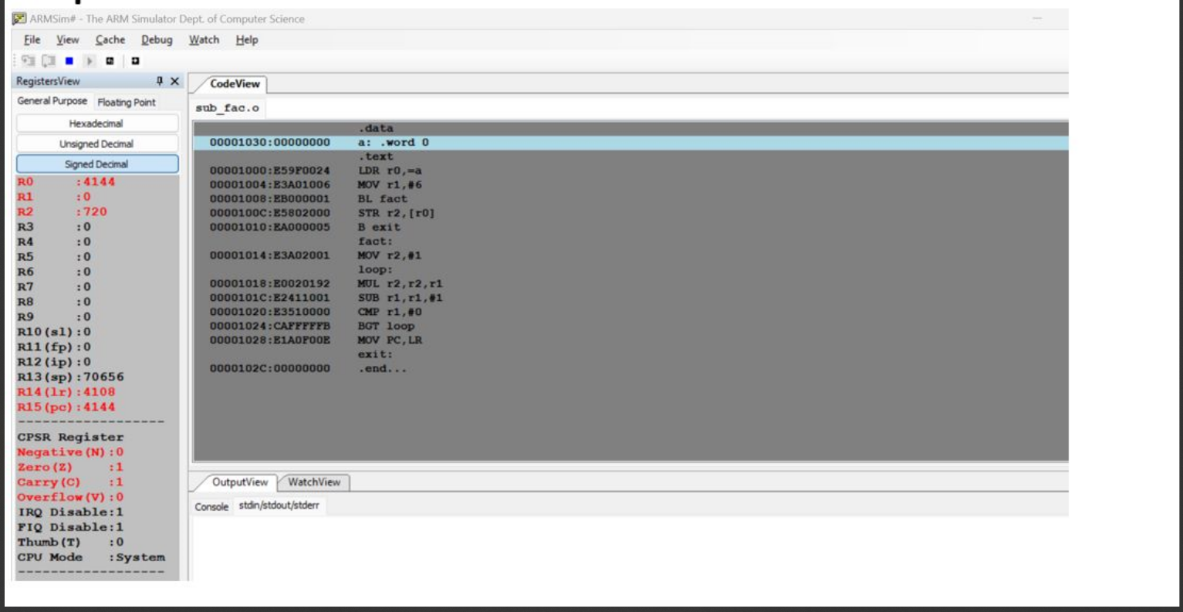

Week#____2_______ Program Number: 8_______

Title of the Program

**Write an ALP to perform multiplication using shift method (without**

**using MUL)**

**Code:**

.text

@25 multiplied by 56

MOV r0,#25

MOV r2,r0,LSL #6

SUB r2,r2,r0,LSL #3

.end

**Output Screenshot:**

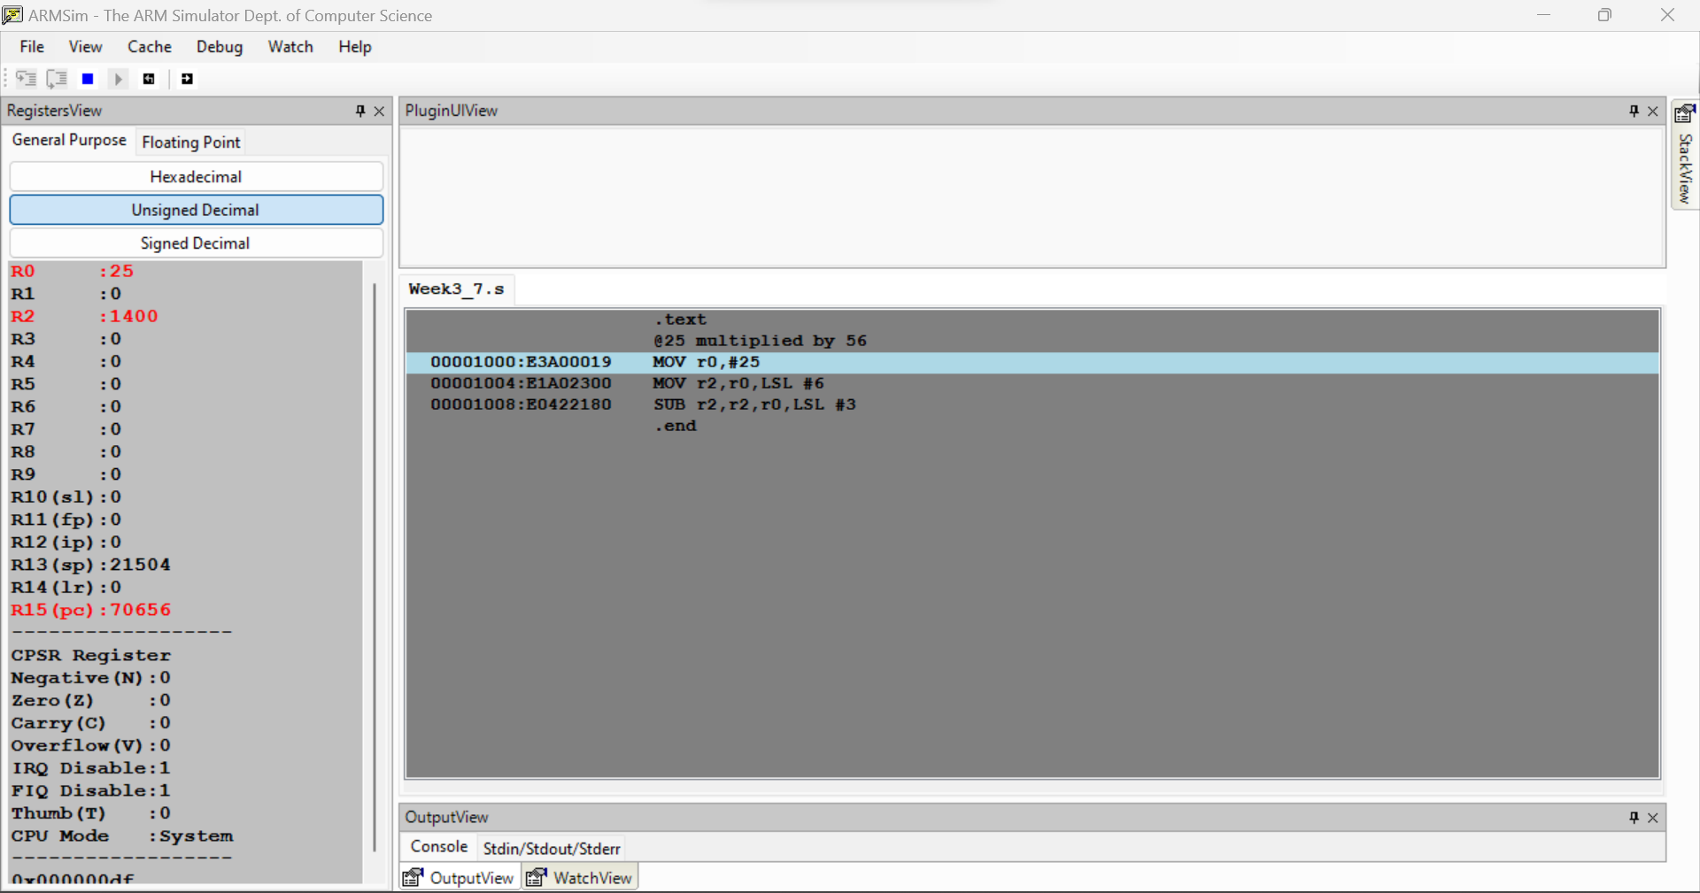

**Disclaimer:**

* The programs and output submitted is duly written, verified and executed by me.
* I have not copied from any of my peers nor from the external resource such as internet.
* If found plagiarized, I will abide with the disciplinary action of the University.

Signature: Atharva Menkudle

Name: Atharva Menkudle

SRN: PES2UG21CS104

Section: B

Date: 9/2/23